Monsieur Marc Pirlot
Director du Bureau Permanent de la C.I.P
Ecole Royale Militaire
Avenue de la Renaissance, 30
1000 Bruxelles
Belgique Date: 22/10/15
Dear Monsieur Pirlot,
The following is a list of calibres that have been homologated through compliance with the C.I.P in regards to an inspection of the facilities, test pressures, dimensions and functional ability for:

Barnes Bullets, LLC
38 North Frontage Road,
PO Box 620,
Mona, UT 84645

As requested by:
The Birmingham Gun Barrel Proof House,
Banbury Street
Birmingham,
B5 5RH

Calibres successfully homologated:
- 260 Remington
- 9mm Browning Court (380 Auto)
- 300 Weatherby Magnum
- 338 Lapua Magnum
- 41 Remington Magnum
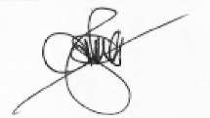
Yours sincerely,
R. J. Hancox
Proof Master

